The Geography Curriculum at Holmfirth High School
Year 11  AQA | Glaciation continued + Tourism in a Glaciated Landscape  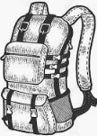 | The Challenge of Resource Management  Food  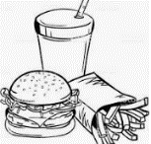 | Urban Issues and Challenges  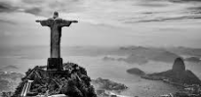 | Issue Evaluation and Pre-release   | The living World  Tropical Rainforests  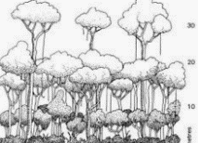
Subject link:  Year:  Link:  7 | Maths  Measuring and construction (complex diagrams/pie charts etc.) | Science  Food Chain  Renewable and one renewable energy |  | Every KS3 and KS4 practical | French, German & Spanish  Free time (describing activities)
8 | Maths  Ratio/proportion and scale | Science  Sources of energy | History  Industrialisation (change in agriculture, transport and industry) | Science  Earth and Climate
9 | Science  Earth’s resources | French and German  Healthy living  Science  Earth’s resources  History  Industrialisation (change in agriculture, transport and industry) |  |  | Science  Photosynthesis
10 | Maths  Foundation  Representing data  Percentages  Higher  Fractions, decimals & percentages  Accuracy & representing data | Combined Science  Energy- Nuclear | PSHE  Trafficking & exploitation  Forced labour & vulnerability | Science  Energy debate
11 | Foundation  Proportional relationships  Using graphs  Higher  Non-linear Graphs | Science  Using earth’s resources  GM and genetic engineering  Using resources |  | Science  Ecology | Languages  Social & global issues  Science  Ecology
Year 10  AQA | The Changing Economic World   | Natural Hazards  Tectonics  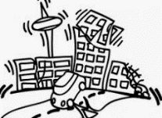 | Coastal Landscapes in the UK + Coastal Fieldwork  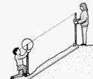 | Natural Hazards  Weather  Climate Change  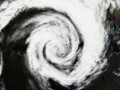 | Glaciation in the UK  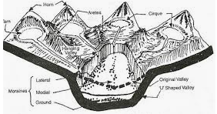
Subject link:  Year:  Link:  7 | Science  Earth resources | French, German & Spanish  Free time (describing activities) | Maths  Measuring and construction (complex diagrams/pie charts etc.) |  | French, German & Spanish  Free time (describing activities)
8 | History  Industrialisation (change in agriculture, transport and industry)  History  The slave trade | Science  Earth and Climate | Maths  Ratio/proportion and scale
9 | Music  Africa  Science  Earth’s resources
10 | History KS4  Britain, health and the people  Business Studies GCSE  Enterprise and entrepreneurship (goods and services)  The economy and business  PSHE  Trafficking & exploitation  Forced labour & vulnerability  Combined Science |  | Maths  Foundation  Representing data  Percentages  Higher  Fractions, decimals & percentages  Accuracy & representing data
11 | Engineering  Project based on mass production  Chemistry  Using resources  Energy  Using earth’s resources |  | Maths  Foundation Proportional relationships  Using graphs  Higher  Non-linear Graphs  Science  Waves | Languages  Key hazard words  Science  Chemistry of the atmosphere
Year 9 | Glaciers and the Ice age   | Asia: China  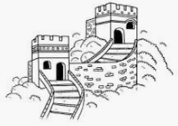 | Restless Planet  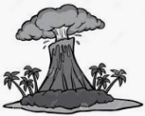 | Earning a living (Globalisation)   | Asia: Middle East  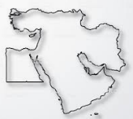
Subject link:  Year:  Link:  7 | French, German & Spanish  Free time (describing activities)
8 |  |  | RPSE  Where did the universe come from | History  Industrialisation (change in agriculture, transport and industry)  The growth of the British Empire | History  Mughal empire- Silk road
9 |  | History-  Communism- Vietnam and Japan/cold war | Science  Earth’s resources  Plate boundaries | Languages  Careers
10 | Science  Energy | Science  Chemical changes  PSHE  Trafficking & exploitation  Forced labour & vulnerability |  | Business Studies GCSE  Business and globalisation | PSHE  Trafficking & exploitation  Forced labour & vulnerability
11 | Science  Using earth’s resources  Chemistry  Using resources  Combined Science | Science  Using resources  Organic chemistry  German  Types of food/working in factories | Science  Inheritance fossils | Languages  Careers
Year 8 | Weather and climate  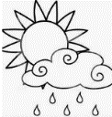 | Food and soil  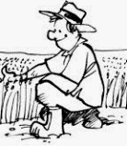 | A tale of 3 cities  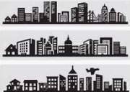 | Fieldwork (Human)  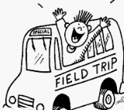 | Climate change and Antarctica  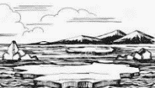
Subject link:  Year:  Link:  7 | Languages  Activities linked to the weather |  |  | Maths  Measuring and construction (complex diagrams/pie charts etc.)  PE  Orienteering | Science  GCSE  Earth and the atmosphere
8 | Science  Earth and climate (including rocks) | Science  Earth and climate (including rocks)  Erosion (soil)  Plant reproduction | History  Industrialisation (change in agriculture, transport and Industry)  Slum housing- at a start of Mughal Empire | Maths  Ratio/proportion and scale
9 |  | French and German  Healthy living  Science  Earth’s resources  Music  Africa
10 |  | Design Technology & Art & Design  Cooking and nutrition  Food and nutrition  Ordering food  Festivals  Healthy living  Science  Infection
11 | Science  Ecology- water cycle | History  Industrialisation (change in agriculture, transport and industry)
Year 7 | Where do we live?  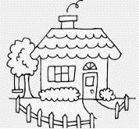 | Our disappearing coast  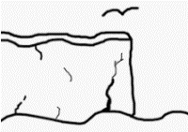 | An unequal world  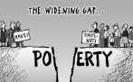 | Fieldwork (Human)   | The environment and resources  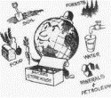
Subject link:  Year:  Link:  7 | History  Holmfirth from the medieval period  Colonisation and the British Empire  PE  Orienteering  Maths  scale revisited throughout | Languages  French, German & Spanish  Free time (describing activities) | English  Travel writing | Maths  Measuring and construction (complex diagrams/pie charts/ percentages etc.)  PE  Orienteering | Science  Energy resources, renewable, non-renewable (fossil fuel formation)  Extinction  French, German & Spanish  Free time (describing activities)
8 | Science  Rock formation | Languages  French, German & Spanish  Holiday’s (past, present and future/transport)  Hobbies | History  Medieval life  The growth of the British Empire  Industrialisation (change in agriculture, transport and industry) | Science  Earth and climate  Lichen fieldwork
9 | Languages  French and German  Describing our local town.  Directions in a local town. | German & Spanish  Holiday’s (past, present and future/transport)  Hobbies |  |  | Science  Environment and resources
10
11 |  | Science  Waves | Languages  Poverty, homelessness & volunteering  Science  Using resources | Science  Transects (Biodiversity)

